Émilie Mayodon

Akash Singh

Sufiyan Mohammad

## Game Proposal

Title: Blitz Breakout

https://cdn.discordapp.com/attachments/623989554533367828/632751422936711178/PurpleSmokeGiphyV2.gif

Tagline: “The light fades out at 3:00”

Studio: Purple Smoke

Genre: Maze, Puzzle, Survival, 2D, Real-Time, 3rd Person, Mystery

Platform: PC Windows, Mac

Target Audience: Everyone 10+

Plays like: Haunted Manor 2 meets Super Mario Bros.

Goal: Escape the depth of the dungeon without running out of time.

Major Mechanics:

1. Puzzle-Solving
2. Platform-based Navigation
3. Jumping
4. Hidden Clues/Dialogues
5. Timed

Setting:

Takes place in the 20st century in Scotland, where the character is stranded in a storm and distinguishes an eerie-looking manor. They call out at the gate, but the ground gives way under their feet, plunging into darkness, only to regain consciousness shackled in a dungeon.

Setting References:

1. *Judge* manga
2. *Saw* film
3. *Corpse Party* anime
4. *Dan the Man* video game
5. *For Honor* video game
6. *Dangerous Dave* video game

Key Experiences:

1. Feel the pressure as the clock ticks down while you attempt to breakout.
2. Descend into the eerie ambience of a forgotten crypt in Scotland.
3. Uncover hidden secrets of a lost manor and its occult past.

Selling Points:

1. The rich storyline will enthrall players.
2. The gloomy environment will entice horror fans.
3. The mind-boggling network of rooms will leave players bewildered.

Related Games:

1. Haunted Manor 2, iOS/Android, redBit games, 2013.

Haunted Manor is a horror game where the player must locate clues by solving complex puzzles hidden in sinister rooms. It has a similar context as Blitz Breakout as it is a puzzle-centered game, but the style differs as HM is a first-person point-of-view and BB is a platformer game in a 2D fashion.

1. New Super Mario Bros., DS/Wii, Nintendo, 2006.

Both of these games are played as platformer games, and a few features in Blitz Breakout is based on Super Mario Bros, such as jumping over objects and gaps. However, BB focuses more on the cryptic atmosphere than fighting enemies and gathering coins.

1. Uncanny Valley, PC/Mac, Cowardly Creations, 2015.

Uncanny Valley has an unsettling aura creating suspense to get the player on edge which can be compared to BB’s ominous ambience, though BB takes more of a supernatural take. They are also both in 2D with a 3rd person point-of-view.

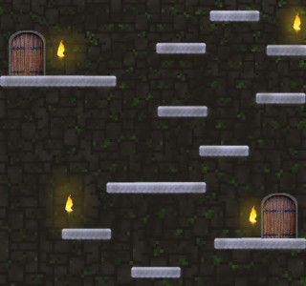Demo of a room: